Module Case 4

Mcgill University
INSY 669 /670: Text Analytics
Instructor: Taha Havakhor

By
Yanjie Gu 261294828
Yangyang Liu 261307787
Dario Guo 261261114
Lawrence Mboutchouang 261112335
Natasha Sujitharaj 261355987

Executive Summary
An analysis of 200 TeePublic reviews was conducted to identify feedback related to sizing and fit. To support the classification process, a 22-term seed list was developed to capture common words and expressions associated with sizing and fit, supplemented by manual checks to improve the identification and labelling of relevant reviews. LDA was also incorporated to identify and label relevant reviews. Three TF-IDF feature sets were then evaluated using a KNN classifier. Cross-validation selected the best-performing model, which used LDA-preprocessed tokens, tokens with unigrams, three neighbours, and cosine distance.
On a test set of 40 reviews, the selected model identified four out of ten sizing-related reviews, demonstrating limited effectiveness in detecting relevant feedback. It performed better at recognizing explicit sizing complaints than shorter comments describing a positive fit. However, its inability to consistently identify sizing-related reviews means it is not suitable as a standalone filtering tool.
It is recommended that TeePublic use the model as an initial screening tool to support manual review rather than relying entirely on automated classification. Further improvements could include expanding the seed list to cover less common sizing terminology and collecting additional manually verified labels to strengthen future model training. These measures could improve the identification of sizing-related feedback and provide more reliable insights into customer experiences.

Methods
We reused the Case 3 cleaning, and lowercased and tokenized the text to normalize the terms. URLs, punctuation, and emojis were not included in lexical inputs, and negation and size codes were retained. LDA Tokens removed stopwords, and shared text did not remove stopwords for n-grams. Stemming and lemmatization were not used to maintain the names and size codes.
LDA setup
We created a document-term matrix with CountVectorizer, resulting in 347 unique words. We wanted to avoid having too many overlapping topics, so we chose to fit two LDA models with 5 and 10 topics. The 10-topic model had a higher coherence score (0.4285) than the 5-topic model (0.3514) so we proceeded with the 10-topic model. We selected Sizing and Fit as our category because Topics contained relevant words such as "size," "sizing," "fit," and "large." We also thought this category would be useful for TeePublic because identifying reviews that discuss clothing fit could help the company better understand customer experiences with sizing. We then used these topic words along with our knowledge of clothing sizes to create a 22-term seed vocabulary for labeling the reviews.
Labeling strategy
We used a hybrid labeling approach, combining weak labeling with manual validation. Using our 22-term seed vocabulary, we assigned an initial label of 1 to reviews that mentioned Sizing and Fit and 0 to reviews that did not. We then manually checked 100 reviews, including all 52 initially positive reviews and 48 randomly selected negative reviews. We identified and corrected 5 incorrect labels, resulting in a 95% agreement rate between the initial and manually verified labels. Our final dataset contained 51 positive reviews (25.5%) and 149 negative reviews (74.5%).
Features
We split the reviews 80/20 (stratified) and fitted all vectorizers on training data only to prevent leakage. Against a unigram-count baseline (970 features), we varied one factor at a time: TF-IDF, bigrams, and vocabulary caps. TF-IDF gave the best same-category similarity separation (pair AUC 0.683 vs. 0.655) by down-weighting common words without adding dimensions. Bigrams quadrupled features (3,948) with no gain and the weakest test coverage. A top-500 cap halved features with no clear loss, while smaller caps lost category signal terms.
KNN tuning
We trained a KNN classifier on TF-IDF features to classify the review’s sentiment. The hyperparameter search considered three values of k: 1, 3, and 5, across both distance metrics. Hyperparameters optimization was performed on the training set using 5-fold stratified cross-validation. Macro-F1was selected as the evaluation metric because it assigns equal importance to each sentiment class, providing a more balanced assessment of model performance.
The tuning process was conducted independently across three feature configurations:
- Unigram TF-IDF on clean_text: represents each review using individual words after text preprocessing.
- Unigram and bigram TF-IDF on clean_text: incorporating both individual words and two-word sequences to capture additional contextual information.
- TF-IDF on topic_tokens: using the topic-oriented token representation to evaluate whether features emphasizing thematic content improve classification performance.
Results
For each feature configuration, all six combinations of k and distance metric were evaluated through cross-validation 5-fold CV on the training set. The configuration with the highest mean macro-F1 score was selected as the best-performing KNN model for that feature set. The selected model was then evaluated on a hold-out test of 40 reviews, which included 10 reviews related to sizing and fit. Since only a quarter of the reviews concerned sizing, accuracy alone could be misleading, as predicting every review “not sizing” would yield 75% accuracy. Therefore, we focused on precision, recall, and F1. This approach allows us to compare the effects of neighborhood size, distance measurement, and text representation systematically, while identifying the most suitable hyperparameter combination for each feature configuration.
As shown in Table 1, the TF-IDF representation of LDA topic tokens with k = 3 and cosine distance achieved the highest mean macro-F1 score (0.757), making it the best performing configuration. However, its performance on the test set was more moderate, it correctly identified 4 out of 10 Sizing & Fit reviews, with 3 false positives (Figure 1 In appendix). Its accuracy was 0.775, only slightly higher than the 0.75 baseline.
The clean-text k = 1 model had a higher test F1 (0.533 vs. 0.471), but it only identified 4 out of 10 Sizing & Fit reviews. We decided to keep the model selected by cross-validation rather than choosing based on test results. Since there were only 10 positive reviews in the test set, the results may not be very reliable.
Error Patterns
As illustrated in the Table 2 (Examples of misclassified test reviews) in the appendix, several factors contributed to these errors. Some Sizing & Fit reviews were incorrectly classified because they only briefly mentioned size, while focusing primarily on other topics like quality and delivery. Additionally, certain relevant words, such as "roomy" and "2xl", were absent from the model’s vocabulary, limiting its ability to recognize these expressions as indicators of sizing-related content. For false positives, two delivery complaints were flagged because 2 of their 3 nearest neighbours were sizing reviews.

Discussion and Managerial Insights
What the classifier gets right and wrong
The model rarely raises false alarms. It correctly ignores 27 non-sizing reviews and wrongly flags only 3, mostly delivery complaints (Figure 1, Appendix). Its weakness is recall: it catches only 4 of the 10 Sizing & Fit reviews. It misses fit comments that appear briefly inside general praise and size words that aren’t in its vocabulary (Table 2).
Precision vs. recall
We evaluate with F1, but recall matters more for TeePublic’s support team. A missed sizing complaint leaves the customer without help and risks a return or a lost customer. A false alarm only adds review work. The model also flags positive fit comments, so staff must still check what it flags. With recall at 0.40, the model shouldn’t be used on its own.
How it changes the workflow
The model could score new reviews daily and send flagged ones to a sizing queue. It could also feed a weekly dashboard by product type (men’s, women’s, youth) to help merchandising spot sizing issues. Labels from support staff and checks on unflagged reviews could then be used to retrain it, improving recall while keeping false alarms manageable.
Appendix
Topics + Coherence Scores Table
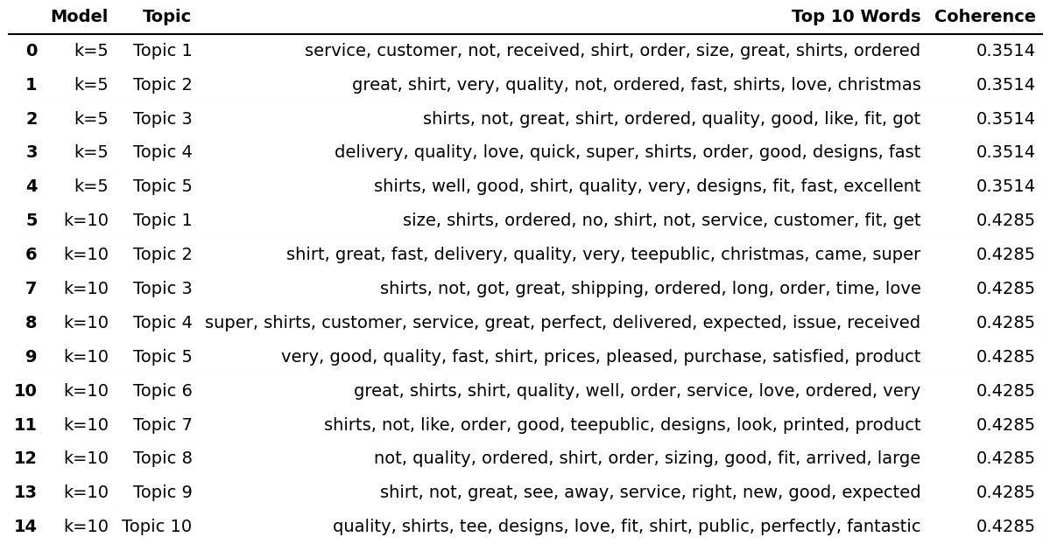
Number of seed terms: 22
Seed vocabulary: ['size', 'sizing', 'fit', 'fits', 'fitting', 'small', 'large', 'tight', 'loose', 'medium', 'xl', 'xxl', 'oversized', 'undersized', 'too small', 'too big', 'true to size', 'runs small', 'smaller', 'larger', 'big', 'bigger']

Table 2: Examples of misclassified test reviews
Review (part of) | True | Pred | Why it was wrong
"Good quality. Received the order super fast. Size was perfect" | 1 | 0 | Sizing is one short phrase; all 3 neighbours are general "good quality, fast shipping" reviews.
"…It's a nice weight tee shirt and extra roomy." | 1 | 0 | Roomy” did not appear in the training data and was therefore absent from the vocabulary; all three neighbours were non-sizing reviews
"My size is always XL but … I had to order 2XL and it's still too tight." | 1 | 0 | "2xl" is also not in the vocabulary; only 1 of 3 neighbours was a sizing review.
"0 of 2 orders arrived at my house. Ordered once, didn't get it…" | 0 | 1 | This delivery complaint was misclassified, this might because two of its three nearest neighbours were labelled as sizing-related reviews.
"Loooove it soo much" | 0 | 1 | No word is in the vocabulary, so the vector is empty and the neighbours are basically random.

Table 1. Best configuration per feature set and test results
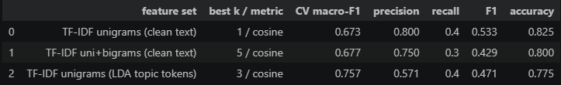

Confusion matrix:
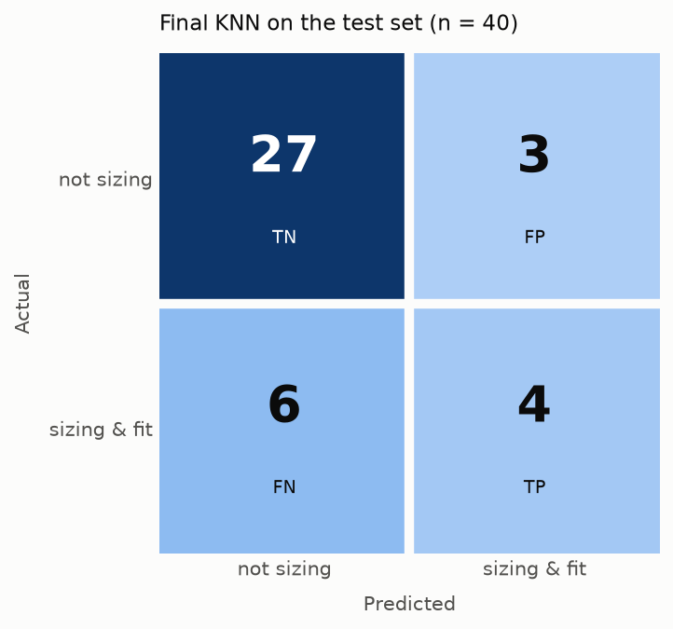
Figure 1. Confusion matrix of the final model (test set n = 40)

Python code and prompts used:
- Repository with code files
- Codex (GPT-6 Astra) was used to assist with writing the code.

